1. Update Your System
Open a terminal and run the following command to ensure your system is up-to-date:
sudo apt update && sudo apt upgrade -y
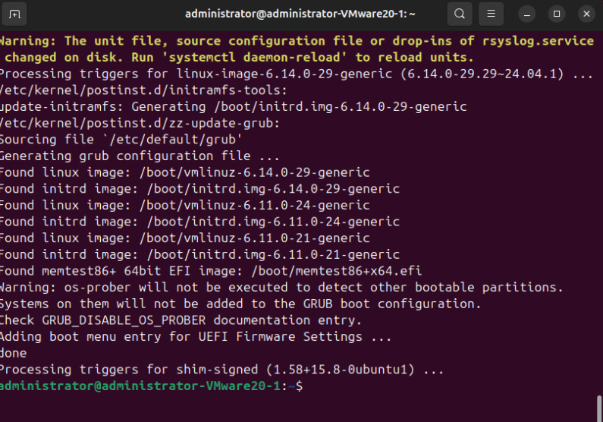

2. Install Required Dependencies
Install necessary packages to allow apt to use repositories over HTTPS:
sudo apt install -y wget apt-transport-https
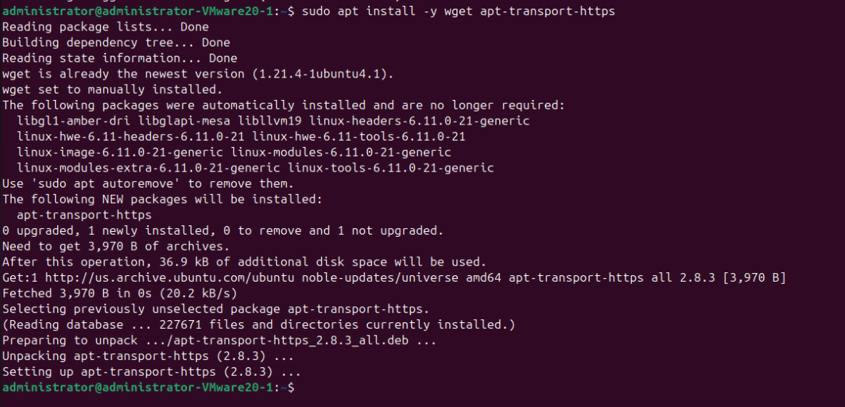

3. Add the Oracle VirtualBox Repository
Download and add the VirtualBox repository key:
wget -q https://www.virtualbox.org/download/oracle_vbox_2016.asc -O- | sudo apt-key add -
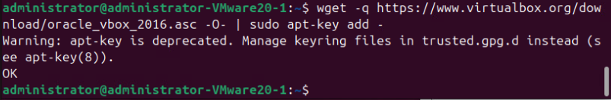
Add the VirtualBox repository to your system:
echo "deb [arch=amd64] https://download.virtualbox.org/virtualbox/debian $(lsb_release -cs) contrib" | sudo tee /etc/apt/sources.list.d/virtualbox.list

4. Update Repositories
Update the apt package list:
sudo apt update
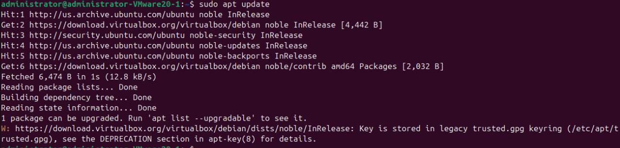

5. Install VirtualBox
Install the latest version of VirtualBox:
sudo apt install -y virtualbox
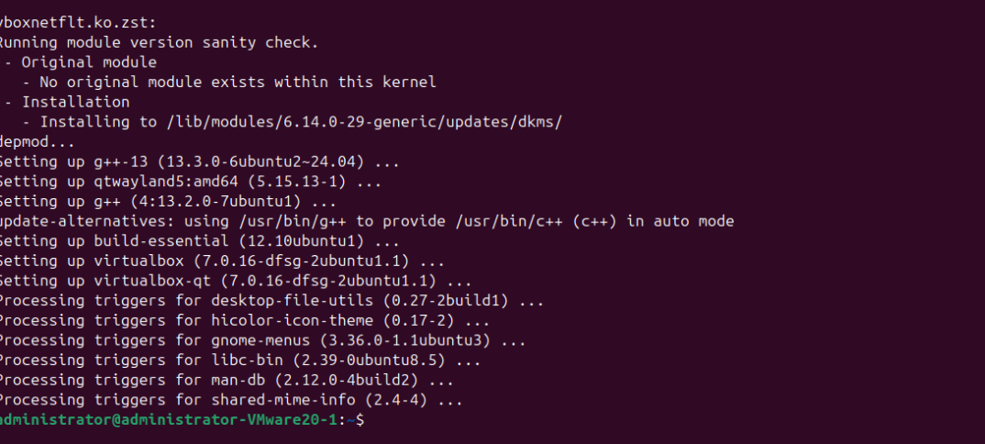

6. Verify Installation
Check if VirtualBox is installed correctly:
virtualbox –version
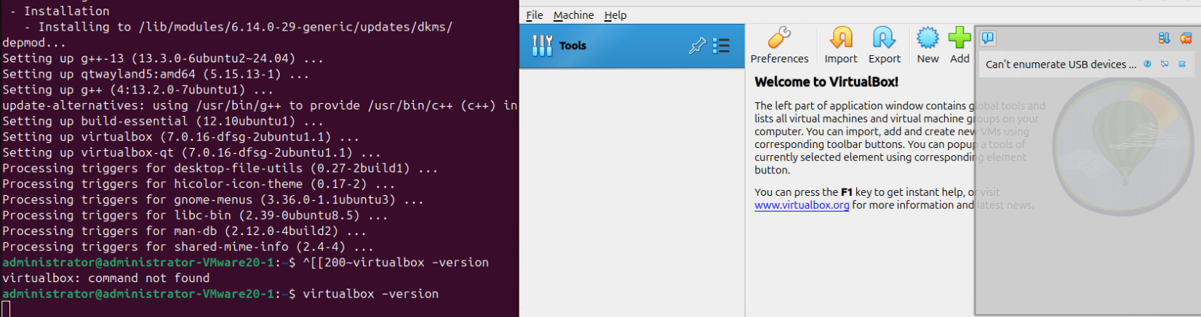
Test VirtualBox access by typing “ virtualbox ” in the directory you installed VirtualBox to.
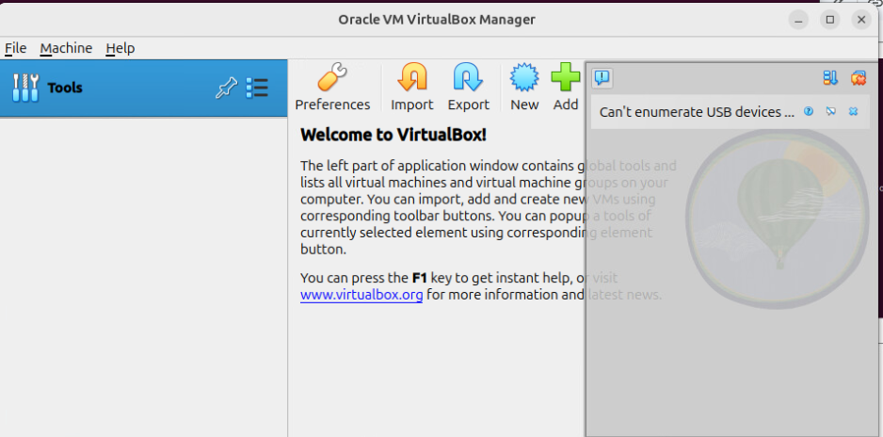

7. Optional: Install Extension Pack
The extension pack provides additional features such as USB 2.0/3.0 support and PXE boot for Intel cards. Download it from the VirtualBox Downloads Page and install it via:
- Open VirtualBox.
- Go to File > Preferences > Extensions.
- Click the + icon and select the downloaded extension pack.

Notes:
- Ensure your system supports virtualization and it's enabled in the BIOS/UEFI settings.
- If you encounter issues, you may need to install additional dependencies like dkms:
sudo apt install -y dkms build-essential
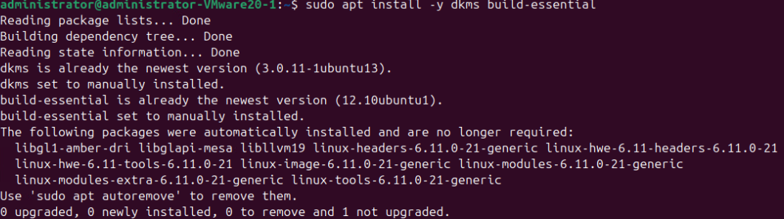

You can download the Ubuntu 22.04 LTS (Jammy Jellyfish) Desktop ISO directly from the official Ubuntu releases page:
- Ubuntu 22.04.5 LTS Desktop (64-bit) ISO:
Ubuntu Releases
This ISO file is suitable for creating a virtual machine in VirtualBox.
Steps to Download and Use the ISO in VirtualBox:
- Download the ISO:
  - Click the link above to download the Ubuntu 22.04.5 LTS Desktop ISO file.

- Create a New Virtual Machine in VirtualBox:
  - Open VirtualBox and click on "New" to create a new virtual machine.
  - Name the VM (e.g., "Ubuntu 22.04").
  - Set the type to "Linux" and version to "Ubuntu (64-bit)".
  - Allocate memory (RAM) to the VM (recommend at least 4 GB).
  - Create a virtual hard disk (recommend at least 25 GB).
- Attach the ISO to the VM:
  - Select the newly created VM and click on "Settings".
  - Go to the "Storage" section.
  - Under "Controller: IDE", click on the empty disk icon.
  - Click on the disk icon next to "Optical Drive" and choose "Choose a disk file...".
  - Select the downloaded Ubuntu 22.04 ISO file.
- Start the VM and Install Ubuntu:
  - Start the VM; it should boot from the ISO.
  - Follow the on-screen instructions to install Ubuntu.
For a visual guide on downloading the Ubuntu 22.04 LTS ISO file, you can watch the following video
